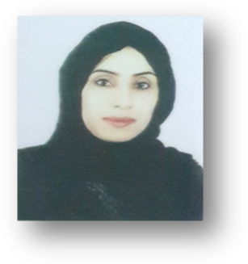
SAFEYA ALI
Curriculum Vitae

Personal Information
Name: Safeya Ali Abdullah Ali
Date of birth: 18/8/1987
Nationality: Bahraini
CPR Number: 870810600
Marital Status: married
Address: House 874, Avenue 3125, Al-Dair 231
Place of Birth: Muharraq
Mobile : 39990623
E-mail: safeya.8@hotmail.com

Education

2009-2015 Bachelor’s degree in accounting and finance at Ahlia university.

Work Experience

2008-2009 Cashier at Fu-com International W.LL.

Skills
Computer programs (Ms. Office)
License

Interest

Drawing
Photography

Languages

Arabic – speaking & writing
English – speaking & writing

